Local Safety Team Meeting Minutes

Name of Team: | MCML Local Safety Team | Chair(s): | Lewis Fausak

Date: | Jul 28, 2023 | Time: | 11:00 AM
 |  | Location: | Remotely via Zoom
AGENDA:
- Roll Call  - Review Central Accident/Incident Reporting System (CAIRS) report of Accidents/Incidents  - Monthly Incident List & Statistical Summary Report  - Review Workplace Safety Inspections (including any changes to equipment, machinery or work processes that may affect the health or safety of workers) | - Review Education and Training  - Ongoing Business – Status of Action Items, Review of Previous Minutes  - New and Other Business  - Next Meeting  - Meeting Adjournment

- ROLL CALL
Worker Representatives | Work Location | Present | Regrets | Absent
Imelda Cheung | MCML |  | ☐ | ☐
Alan Lee | MCML | ☐ |  | ☐
Sylvia Leung | MCML |  | ☐ | ☐
Jimmy (Juli Carillo’s grad student) Kyu Ha | MCML |  | ☐ | ☐
Lewis Fausak | MCML |  | ☐ | ☐
Thorsten Knipfer | MCML |  | ☐ | ☐
Jack Edgar | MCML | ☐ | ☐
Peter Kalynyak | MCML/Plant Care |  | ☐ | ☐
Employer Representatives | Work Location | Present | Regrets | Absent
Andy Jeffries | MCML | ☐ |  | ☐
Resources/Guests | Work Location | Present | Regrets | Absent
Samuel Holden | MCML |  | ☐ | ☐
Ishwinder Kamboj | MCML | ☐ | ☐

Approve Previous Month’s Minutes? Yes No ☐

- REVIEW CAIRS REPORT OF ACCIDENTS/INCIDENTS:
See attached incident report:
Monthly Incident List & Statistical Summary Report (make note of trends etc. For any general CAIRS information that requires discussion or action, please record under “New Business”. Any incident specific items and follow up requests are to be listed below)
(* See Legend at end for Priority and Status Codes)
Item #  (Use CAIRS Incident ID #) | Priority | Date | Action Plan  (Actions Taken/Need to be taken) | Assigned To | Follow up: Date Pending | Status
ID# 130900-130902 | E | March 2023? | Soap in eyes of employee at GH. Will have to follow up with PK. Need safe procedures put in the SOP. | PK | May 31, 2023 | IP

- REVIEW OF WORKPLACE SAFETY INSPECTIONS (including any changes to equipment, machinery or work processes that may affect the health or safety of workers)
Inspections for June: 214,218 (IC), 192/194 (IC/LF/AJ), Greenhouse and Totem (MB,TS,AJ,LF,IC), MCML Office and common space Inspections (AJ/LF/IC)
Inspections for July: MCML 102, 112, 118, 120 (LF), MCML Exterior, Stairwells, General Interior (AJ/LF)
Inspections for August: MCML 66 (IC), 130, 136, 180, 302, 308 (LF)
Item #  (Use Inspection #) | Priority | Discussion/Comments/Recommendations | Assigned To | Follow up: Date Pending | Status
MCML 308  M-46 | C | Chemicals in 308B are stored alphabetically and not by hazard class. Review chemical inventory and organize chemicals by hazard class. Lan will look up SDSs and the hazard class for each chemical in the space and tabulate in a google sheet. The information has been shared with Peter K. | PK/LF/IC | May 31, 2023 | IP
MCML 180F  D-17 | C | A big hole in the ceiling was covered with duct tape. It is located at the left corner of the room. Have it assessed prior to submitting a service request to get it fixed. Consult with Andy. Service request has been submitted. Space was inspected, AJ met with crew members. AJ to contact SALA to inspect upstairs space. Do not see immediate concern as of now. | AJ | July 31, 2023 | IP
MCML 144/148  M-18 | C | Countertops in MCML 148C are cracked and could be a potential danger due to splintering. Repair or replace countertops. SR submitted; will take time for carpenter to schedule. | AJ,AL,JE,LF | July 1, 2023 | IP
MCML 144/148  M-18 | C | Fumehood sashes in MCML 148C, 148A and 148G have wood on the airfoil sill, which is porous and could lead to potential contamination. Cover sills with metal plate to reduce risk of chemical contact. | AJ,AL,JE,LF | July 1, 2023 | IP
MCML 202  M-31 | A | Fume hoods in 202 lab are not working. AJ will submit a service request to have the fume hoods repaired. SRS is still in the process of repairing them. One is done but the other is still locked out. AJ will connect with SRS to come for an inspection. IC will email Alan to confirm. AL has confirmed that all fume hoods in 202 are operational. | AJ | Aug 4, 2023 | C
MCML 64  D-3 | B | Light casing is not secured; submit service request to tighten casing. The casing is secured and the item is complete. | LF | July 28, 2023 | C
MCML 220, A-C  M-7,8 | B | Eyewash station and emergency shower are not available in this lab due to renovations. The nearest eyewash station and emergency shower is located in MCML 214. However, the eyewash station in MCML 214 was not inspected in 2022. Inform all lab-users of the location of the nearest eye wash station, schedule inspection for the eyewash station located in MCML 214. | AJ/IC | July 31, 2023 | N
MCML 220D  M-46 | C | Biological and sharp waste were left in an unlabelled bin on the ground. Schedule waste clean up. IC has placed the biological waste in the pathological freezer for pick-up. The sharp wastes still need to be tagged by Gurcharn’s lab for proper disposal. IC will show SH to get rid of them. | IK/SH | July 31, 2023 | N
MCML 220D  M-46 | B | Many bottles of peroxide formers are placed in cabinet. Determine whether the chemicals are safe for testing, then follow regular testing schedule of the peroxide formers to determine whether they need to be disposed of. The peroxide test strips have been purchased. | IC | Aug 31, 2023 | N
MCML 240  M-25 | C | Distilled deionized water system is set up on the bench top, on top of a stool. Could be dangerous to reach with risk of falling even with the presence of a ladder. Find an alternative for the system set-up. This will be mitigated once the system is installed in MCML 230 – hopefully in late July. Currently IC has surrounded the area with stools so no one will be near the approximate area unless ddwater is being prepared. | IC | July 31, 2023 | N
MCML 102C  D-10 | C | Bookshelves are not secured to the wall, not earthquake safe. Submit a service request to ecure bookshelves to the wall as soon as possible. | LF | July 28, 2023 | C
MCML 102C  D-11 | C | Heavy boxes are placed above unsecured bookshelves, not earthquake safe. Relocate heavy boxes as soon as possible. | LF | July 28, 2023 | C
MCML 118A  D-3 | C | The light closest to the window and door is not functioning. Submit a request to replace bulb as soon as possible. | LF | Aug 31, 2023 | N
MCML 123  D-2 | C | There are two loose tiles which are tripping hazards. Secure tiles to the floor as soon as possible. | LF | Aug 31, 2023 | N
MCML 124  D-7 | C | Vent is occasionally very noisy, can be disruptive to students. Schedule check up of the venting system. | AJ | Aug 31, 2023 | N
MCML 124  D-11 | C | Microwave is placed on top of the fridge. The base of the microwave is larger the fridge’s, it is not earthquake safe. Relocate microwave. | Users | Aug 31, 2023 | N
MCML 124  D-3 | C | Light located on the left closest to entrance is not functioning. Submit a request to replace bulb as soon as possible. | AJ | Aug 31, 2023 | N
MCML 124  D-17 | C | Cover of one drawer of Gurcharn’s desks is detached. Attach cover back on. | AJ | Aug 31, 2023 | N
MCML 124  D-17 | C | Interior of the microwave is dirty. Clean microwave, schedule regular cleaning. | Users | Aug 31, 2023 | N
MCML 129, 135, 137, 140, 156B,C, 233  D-17 | C | Office chair is old. Find replacement chair. (Also 302B student chairs) | AJ | Aug 31, 2023 | N
MCML 133  D-11 | C | Binders placed too high on top of shelves, not earthquake safe. Remove and relocate binders from shelve immediately. | David M/LF | Aug 31, 2023 | N
MCML 136D  D-10 | C | Three bookshelves are not secured, two shelves stacked on top of each other (not secured), not earthquake safe. Secure bookshelves, relocate the stacked shelves. Some renovations and reorganization of desks/shelves will be done over August to make space more suitable for graduate student use. | AJ | Aug 31, 2023 | N
MCML 136D  D-11 | C | Two monitors are placed up high on shelves. Relocate monitors. They are moved to a lower position and this item is complete. | AJ | July 28, 2023 | C
MCML 136D  D-17 | C | Office is messy and cluttered. General clean up schedule should be enforced. New signage to enforce tidy and clean space – emoji or anything. Provide cleaner and tools to facilitate clean up. These suggestions apply to all common spaces. Monthly inspection of space rotated by PIs. | AJ | Aug 31, 2023 | N
MCML 136E  D-10 | C | Bookshelf not secured, not earthquake safe. Secure bookshelf as soon as possible. | AJ | Aug 31, 2023 | N
MCML 136E  D-11 | C | Heavy boxes placed on top of unsecured bookshelf, not earthquake safe. Relocate heavy boxes. | AJ | Aug 31, 2023 | N
MCML 137  D-11 | C | Big heavy boxes are placed on top of shelves, not earthquake safe. Remove or relocate boxes. | AJ | Aug 31, 2023 | N
MCML 148/D  D-3 | C | The light closest to the window is not functioning (In 148). Submit a service request to replace light. | AJ | Aug 31, 2023 | N
MCML 156B/C  D-17 | C | Chipped wall painting and holes present. Paint walls and fill holes on wall. | AJ | Aug 31, 2023 | N
MCML 208/B  D-3 | C | Light closest to door is not functioning (in 208B). Submit a service request to replace light. | AJ | Aug 31, 2023 | N
MCML 208/B  D-10 | C | Shelves in 208B are not secured. Secure shelves as soon as possible. | AJ | Aug 31, 2023 | N
MCML 208/B  D-7 | C | Vent is dirty and noisy (208B). Schedule regular check up for ventilation system. | AJ | Aug 31, 2023 | N
MCML 208/B  D-17 | C | Office is messy (208B). Clean office, regular cleaning schedule should be implemented. | SL | Aug 31, 2023 | N
MCML 214C,D  D-11 | C | Heavy box placed up top, not earthquake safe (in 214C). Remove or relocate boxes. | IK | Aug 31, 2023 | N
MCML 221  D-17 | C | Live insects present in a box with an unsecured lid. Relocate box with live insects. | YA | Aug 31, 2023 | N
MCML 223  D-17 | C | Office user feels cleaning is not done frequently enough, there are spiders by the window area. Check in and revise cleaning schedule. | AJ | Aug 31, 2023 | N
MCML 225  D-4 | C | Blinds are not functioning properly. Schedule regular check up and fix blinds as soon as possible. | AJ | Aug 31, 2023 | N
MCML 233  D-11 | C | Heavy items placed up top, not earthquake safe. Remove or relocate heavy items. | AJ | Aug 31, 2023 | N
MCML 237  D-3 | C | Light is too dim; submit a service request to replace bulb. | AJ | Aug 31, 2023 | N
* GI- General Inspection

- EDUCATION AND TRAINING

Recommended items to discuss at JOHSC/LST Meeting
Safety Day Agenda and Registration
The Safety Day Agenda has been finalized and attached. Registration is filling up fast, with over half of our spots taken, so register now to ensure you don’t miss Safety Day on October 3rd, 2023! All the information about the day can be found on the website.

Safety Day Voting for Awards and Registration
The Safety Day award nominations have closed and we have compiled all of the nominations for this year! Please click the voting link to review each nomination and vote for 2 JOHSCs and 2 LSTs to win the Safety Achievement Award. The deadline to vote is Friday September 1, 2023.

Safety Day is more than 2/3 full! Thank you to those who have already registered. For those who haven’t, visit the website to find out more about the day and how to register: https://safetycommittees.ubc.ca/safety-day-2023/.

Asbestos Awareness Course Launch
A new SRS created “Asbestos Awareness” course is now online. This course was developed to enhance knowledge about asbestos and its management program on the Point Grey Campus. The Asbestos Awareness course is available through the WPL platform and further information about the Asbestos Management Program is available on the SRS Website .

Active Wellbeing Toolkit
Are you interested in fostering a team culture that prioritizes health and wellbeing while enhancing workplace engagement and productivity? UBC’s new Activate Wellbeing Toolkit will help you identify actionable and measurable steps to integrate health and wellbeing into your unit and portfolio strategic planning, contributing to healthier work and learning environments. Learn more at https://wellbeing.ubc.ca/awt.

Weather and Thermal Stress Safety
UBC has taken steps to plan for extreme heat events. Given the recent high temperatures, we wanted to highlight the resources and information to help you and your loved ones stay cool and safe. The following air-conditioned UBC buildings are open to the public:
- Irving K. Barber Learning Centre (Monday-Sunday, 6:00 a.m. to 12:00 a.m.)
- Koerner Library (Monday-Thursday, 7:30 a.m. to 8:00 p.m.; Friday, 7:30 a.m. to 5:00 p.m.; Saturday and Sunday, closed)

Visit the Weather and Thermal Stress Safety page for the most updated information about UBC’s on-campus cooling centres.

Informational Items

JOHSC and LST Training
New dates have been released for JOHSC and LST training. You can register for JOHSC training here, and LST training here.

JOHSC Training |  | LST Training
Part 2a | Part 2b | Part 2a | Part 2b
September 11th  10:00am – 12:00pm | September 13th  1:00pm – 3:00pm | August 16th  11:00am – 12:30pm | August 18th  1:00pm – 2:30pm
TBD | TBD | TBD | TBD

WorkSafeBC Inspection Reports (IR)
There was 5 WorkSafeBC Inspection Reports received since the July co-chair email and 3 reports since August. As always, the “WSBC IR Summary” attachment provides a brief summary for the inspection reports and some discussion points to consider.
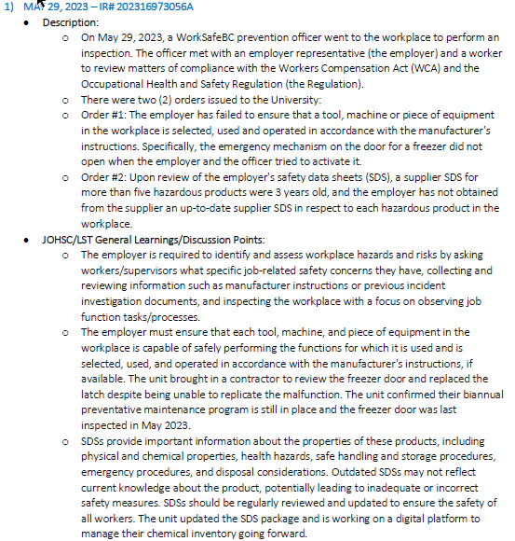
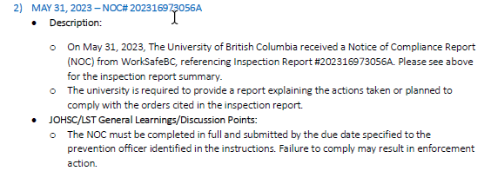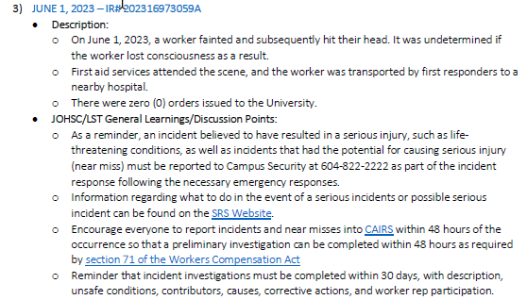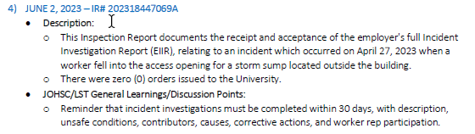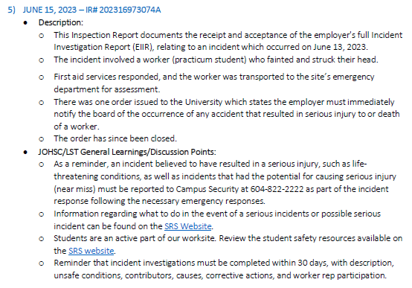
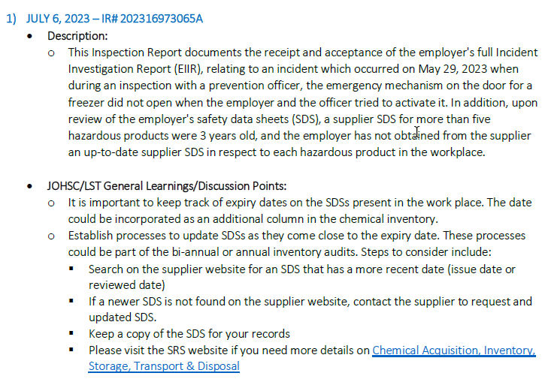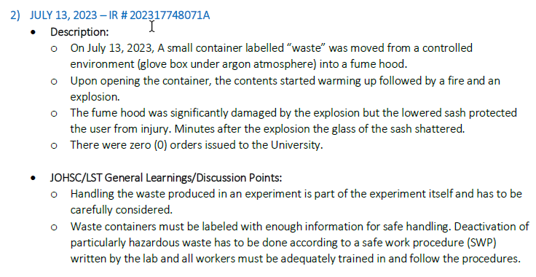
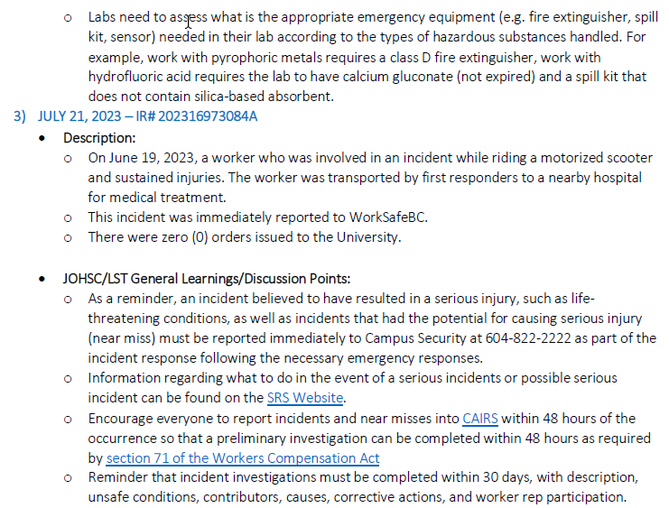

Sustainability Tips
None

- ONGOING BUSINESS – Status of Action Items (includes review of previous meeting minutes)
Items from JOHSC / RMS or other?
Original Item # | Priority | Action Plan  (Actions Taken/Need to be taken) | Assigned To | Follow up: Date Pending | Status
155 | C | Chemical Amnesty program and old gas cylinder disposal. The chemical amnesty program has successfully removed many hazardous and dated chemicals from both the MCML and FNH building at no cost to LFS. Further arrangement with SRS will remove dated gas cylinder situated at MCML gas room. AJ will follow up to see if this is a possibility. SRS may have run out of budget. AJ will check. | AJ | May 31, 2023 | IP
157 | C | Schedule a fire drill in June/July. After consulting with the floor wardens, the date is officially set on Aug 10th at 10 am. | AJ | July 13, 2023 | C
159 | C | MCML 214/218 Brar Lab. Space was undergoing renovation at the time of visit so no inspection was performed. It is recommended that a visit be scheduled with SRS to complete the inspection once lab is set up. | IK | Aug 31, 2023 | IP
161 | C | MCML 102/112/120 Chemical Storage. It is recommended that peroxide formers be tested according to required scheduled.  For more info please see: chemical-safety-resources. Testing of peroxide formers must be documented on the peroxide former bottles. Each lab should identify the list of peroxide formers in the lab, categorize them by their class below.  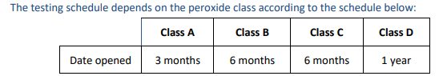  Once complete, each peroxide formers must be tested according to this schedule until they are completely consumed. Please check the below document for all peroxide formers: https://riskmanagement.sites.olt.ubc.ca/files/2023/04/CHEM-SWP-011-Working-Safely-With-Peroxide-Forming-Compounds-PDF.pdf | LF | Jun 30, 2023 | IP
162 | C | MCML 102/112/120 Chemical Storage. It is recommended that compressed gas cylinders be added to the inventory on Quartzy. | LF | Aug 31, 2023 | IP
163 | C | In the compressed gas room, all cylinders must be secured. If needed, SRS can provide custom solutions for small cylinders. AJ said most small cylinders are ready to go so SL can call for them to pick up the empties. | AJ | Jun 30, 2023 | IP
164 | C | Despite hydrogen gas and oxygen gas being stored in separate corners of the compressed gas room, it is highly recommended that they store in separate rooms. Investigate if this can be achieved. AJ will do an inventory of the gas room to see whether some tanks can go. | AJ | Jun 30, 2023 | IP
165 | C | MCML 308 Riseman Lab. It is recommended that chemicals are segregated by hazard classes. This can be combined with the above item. | PK | Jun 30, 2023 | IP
166 | C | MCML 308 Riseman Lab. This lab stores a large variety of oxidizers; they either need to be stored in a secondary container or be in a separate storage area. | PK | Jun 30, 2023 | IP
167 | C | MCML 202 Smukler Lab. It is recommended that chemicals are segregated by hazard classes. This is complete. | AL | July 28, 2023 | C
168 | C | MCML 202 Smukler Lab. The reference to solvent storage should be removed in the cabinet that now stores oxidizers. The label has been removed. | AL | July 28, 2023 | C
169 | C | MCML 202 Smukler Lab. Gas cylinders in the lab should be added to the inventory. The nitrogen gas cylinder is now entered into Quartzy inventory. | AL | July 28, 2023 | C
172 | C | MCML 220-240 FNH Teaching Labs. Chemicals should be segregated by hazard classes. The chemical storage space is currently under renovation. Once complete, the chemicals will be segregated according to hazard class – the list has been identified and tabulated. Chili will work on segregating the chemicals by hazard class, then alphabetically within each class to be ready for proper segregation into new chemical storage space. Chili has helped to segregate the chemicals by hazard class and will be ready to move appropriately into the new chemical storage space when renovation is done. | IC | July 28, 2023 | C
174 | E | Safety Day Agenda 2023. Register for Safety Day 2023. Other information can be found at Safety Day Webpage  Awards  Awards will be presented at the end of the day. Two JOHSCs and two LSTs will have the opportunity to win the “Safety Achievement Award.” To nominate your JOHSC/LST for the award, please submit your nomination using the link below by Friday July 14. We strongly encourage that you open up the link during your meeting and fill it out during your meeting. No achievement/accomplishment is too small!  https://ubc.ca1.qualtrics.com/jfe/form/SV_cYk6IisHRuGSpAW  This year we are encouraging JOHSCs/LSTs to nominate themselves and then SRS will take the nominations and transcribe them into a new Qualtrics survey that will be sent out in the August co-chair email for the committee/team members to vote on who they think should win the award.  LF has submitted a nomination on behalf of the LFS JOHSC. | IC | Jun 30, 2023 | C
175 | C | To address concerns for items in MCML 59 and 62, AJ will create a checklist to encompass them and discuss with the Agora team at the beginning of each academic term to ensure the health and safety concerns are addressed and checkout procedures are followed: 1) Floor stains – deep cleaning is needed at the end of each term; 2) Grey water left in the sink and garbage bin not emptied – Agora café and room 62 should be properly cleaned and sanitized every end of day; deep cleaning is needed at end of each term; 3) Produce and any perishable should be disposed of prior to shutting down the Agora Café in March – it’s a serious health and safety concern to leave perishable in these spaces from March till September. | AJ | Aug 31, 2023 | IP

- NEW & OTHER BUSINESS
Items from JOHSC / RMS or other?
Item # | Priority | Discussion and/or Action Items | Assigned To | Date to be Completed | Status
176 | C | Reiterate the importance of PIs to be aware of all the health and safety protocols enforced in the lab. Some examples include safety features in labs, where are chemical inventory located, where are the safety data sheets, what are the emergency protocols and contact numbers, etc. It is important that this information is delivered to all students and staff working in each space so if an external inspection does come through, students, staff and PI will know the information. Circulate this reminder via LFS Today and target all PIs and lab managers in the building. | LF/IC | Aug 31, 2023 | N
177 | C | Check whether each lab has a site-specific safety orientation in place – Carly and Ishwinder/Samuel. | LF/IC | Aug 31, 2023 | N
178
.

- NEXT MEETING
Date: | Aug 25, 2023
Time: | 11:00 AM
Location | Remotely via Zoom or MCML 139

- MEETING ADJOURNED
Time: | 11:57 am

LEGEND

PRIORITY: |  | STATUS:
A | Critical/Life threatening/high probability | N | New
B | Urgent/moderate probability of re-occurrence | R | Repeat
C | Important/low probability of re-occurrence | C | Complete
D | Reminders | IP | In Progress
E | Information | RF | Referred forward

Send a copy of the meeting minutes report to the JOHSC. Highlight important items that must be reviewed/discussed at next JOHSC meeting.

Monthly Distribution and Posting of Approved Meeting Minutes (Required):
- All LST members
- Appropriate JOHSC
- Risk Management Service

