Local Safety Team Meeting Minutes

Name of Team: | MCML Local Safety Team | Chair(s): | Lewis Fausak

Date: | Jan 19, 2024 | Time: | 11:00 AM
 |  | Location: | Remotely via Zoom

LAND ACKNOWLEDGMENT:
I would like to acknowledge that UBC’s Vancouver Point Grey campus is situated on the traditional, ancestral, unceded territory of the Musqueam people. I would also like to acknowledge that you are joining us today from many places, near and far, and acknowledge the traditional owners and caretakers of those lands.

AGENDA:
- Roll Call  - Review Central Accident/Incident Reporting System (CAIRS) report of Accidents/Incidents  - Monthly Incident List & Statistical Summary Report  - Review Workplace Safety Inspections (including any changes to equipment, machinery or work processes that may affect the health or safety of workers) | - Review Education and Training  - Ongoing Business – Status of Action Items, Review of Previous Minutes  - New and Other Business  - Next Meeting  - Meeting Adjournment

- ROLL CALL
Worker Representatives | Work Location | Present | Regrets | Absent
Imelda Cheung | MCML |  | ☐ | ☐
Alan Lee | MCML |  | ☐ | ☐
Sylvia Leung | MCML |  | ☐ | ☐
Jimmy (Juli Carillo’s grad student) Kyu Ha | MCML |  | ☐ | ☐
Lewis Fausak | MCML |  | ☐ | ☐
Thorsten Knipfer | MCML | ☐ |  | ☐
Jack Edgar | MCML | ☐ | ☐
Peter Kalynyak | MCML/Plant Care | ☐ |  | ☐
Samuel H. |  |  | ☐ | ☐
Employer Representatives | Work Location | Present | Regrets | Absent
Andy Jeffries | MCML |  | ☐ | ☐
Resources/Guests | Work Location | Present | Regrets | Absent
Melina Biron | Plant Care | ☐ |  | ☐

Approve Previous Month’s Minutes? Yes No ☐

- REVIEW CAIRS REPORT OF ACCIDENTS/INCIDENTS:
See attached incident report:
Monthly Incident List & Statistical Summary Report (make note of trends etc. For any general CAIRS information that requires discussion or action, please record under “New Business”. Any incident specific items and follow up requests are to be listed below)
(* See Legend at end for Priority and Status Codes)
Item #  (Use CAIRS Incident ID #) | Priority | Date | Action Plan  (Actions Taken/Need to be taken) | Assigned To | Follow up: Date Pending | Status

- REVIEW OF WORKPLACE SAFETY INSPECTIONS (including any changes to equipment, machinery or work processes that may affect the health or safety of workers)
Inspections for December: 192/194 (IC/LF/AJ), MCML 66 (IC), Greenhouse and Totem (MB,TS,AJ,LF,IC), MCML 22,A/B,26,34,48C/D/G/H (AJ/LF); MCML 320 (LF), MCML 180E (AJ/IC)
Inspections for January: None
Inspections for February: None
Item #  (Use Inspection #) | Priority | Discussion/Comments/Recommendations | Assigned To | Follow up: Date Pending | Status
MCML 220D  M-46 | B | Many bottles of peroxide formers are placed in cabinet. Determine whether the chemicals are safe for testing, then follow regular testing schedule of the peroxide formers to determine whether they need to be disposed of. The peroxide test strips have been purchased. | IC | May 31, 2024 | IP
MCML 180F  D-3 | C | light panel cover is missing; submit service request to attach cover. There is no cover to replace because of how dated the design is. | AJ | Jan 19, 2024 | C
MCML 191  D-3 | C | 1 light panel is not working; submit service request to replace light. | AJ | Jan 19, 2024 | C
MCML 270  D-3 | C | light panel in the hallway is twitching; submit service request to get it fixed. | AJ | Jan 19, 2024 | C
MCML 302B  D-3 | C | 2 light panels closest to bookshelf are not working; submit service request to replace lights. | AJ | Sept 30, 2023 | IP
MCML 344  D-3 | C | light panel closest to the TV is not working; submit service request to replace light. | AJ | Jan 19, 2024 | C
MCML 366  D-3 | C | light switch does not work; submit service request to fix. | AJ | Sept 30, 2023 | IP
MCML 123  D-2 | C | There are two loose tiles which are tripping hazards. Secure tiles to the floor as soon as possible. LF submitted SR. | LF | Jan 19, 2024 | C
MCML 136D,E  D-10,11,17 | C | Three bookshelves are not secured; Heavy boxes placed on top of unsecured bookshelf, not earthquake safe; Office is messy and cluttered. All the items have been combined into one. The office space will be tidied up and transformed into a general soil science student space. LF will schedule meeting with AJ and AB/ZN to discuss steps going forward. General clean up schedule should be enforced. New signage to enforce tidy and clean space – emoji or anything. Provide cleaner and tools to facilitate clean up. These suggestions apply to all common spaces. Monthly inspection of space rotated by PIs. Awaiting for last graduate student to complete before major work on the space. Filing cabinet to be moved to make the space safe in the interim. | AJ/LF | Feb 28, 2024 | IP
MCML 318D  D-10 | C | bookshelf is not secured; submit service request to get it secured. Need to check if the bookshelf is kept and if so, then secure it. | AJ | Feb 28, 2024 | IP
MCML 233  D-11 | C | Heavy items placed up top, not earthquake safe. Remove or relocate heavy items. AJ will repurpose this room in the next month or so. | AJ | Feb 28, 2024 | IP
MCML 214/218  M-14 | B | Door signage does not reflect the hazard in the lab. Oxidizers and compressed gases are not used in the lab while biosafety level 1 materials are handled in the lab. IC recommends the lab to complete the application of biosafety permit prior to requesting the door signage update. Once complete, IC will assist the lab to submit the door signage update form to UBC SRS to get this updated. | IC/IK/SH | Feb 28, 2024 | IP
MCML 214/218  M-19 | C | All staff and students complete mandatory training by UBC SRS and LFS. However, a lab specific orientation is missing for specific health and safety coverage in the space. The lab should look at the LFS Lab Guide and adapt it to the lab and consistently provide this orientation to newcomers to the lab. Existing staff and student should go through the Guide and ensure they understand all the information. The specific orientation has been prepared so everyone currently in the lab have to go through that and document properly in a binder with signature, or publish on TRMS per person. SH is going through the orientation every lab meeting. Everyone in the lab have got the orientation. | IC/IK/SH | Jan 19, 2024 | C
MCML 214/218  M-39 | B | Biosafety permit is not posted in the space. It is noted that the approval process may not have been complete since submission in late March 2023. SH will follow up on the status of the application. Once approved, the biosafety permit must be posted on the BSC. SH is facilitating the process by following up on each deficiency. Progress will be updated next meeting. | IC/IK/SH | Aug 30, 2023 | IP
MCML 190D  D-8 | B | electrical port cover is missing, cables are exposed. Wires are poking out from the wall and uncovered. Submit service request to attach electrical port cover as soon as possible. It’s a data port but not live, dead low voltage wire. Put a network port cover. | AJ | Nov 30, 2023 | IP
MCML 336  D-2 | C | wire dragged across the floor, tripping hazard; Secure wire such that it will not pop up. | AJ | Jan 19, 2024 | C
MCML 308  M-46 | C | Chemicals not segregated by hazard class, this is an ongoing task for the lab manager and LST. This lab stores a large variety of oxidizers; they either need to be stored in a secondary container or be in a separate storage area. This will require a large amount of time and will postpone till summer 2024. | LF/IC | May 31, 2024 | IP
MCML 144/148  M-16 | C | Shelves used for drying samples are not secured to wall. Submit service request to anchor shelves to wall and then anchor floating shelves to anchored shelves. Reorganization still in progress – wait until locations of shelves are final prior to securing them to wall. | AJ/LF | Feb 28, 2024 | IP
* GI- General Inspection

- EDUCATION AND TRAINING

Recommended items to discuss at JOHSC/LST Meeting (October)
Lead Exposure Control Plan and Training Course
Exciting News! SRS is launching an updated UBC Lead Exposure Control Plan (ECP) and a new Lead Awareness training course. This ECP and the associated training is intended specifically for supervisors, workers, and students who are likely to come into contact with lead or lead containing products. The document will provide information on the hazards associated with lead and provide guidance on exposure control measures.

Preparing for Extreme Winter Weather at UBC
As per the Snow Policy, if UBC is subject to extreme winter weather conditions, the Deputy Vice‐Chancellor of each campus or his/her delegate may decide to cancel or reschedule classes and/or curtail non-essential services. You are advised to regularly check the following website: https://www.ubc.ca/ in the event of extreme weather.

Facilities’ Municipal Services and Custodial Service teams provides ice prevention and snow removal services on the Vancouver Campus. Visit the website to see a map that identifies priority roads, sidewalks and pathways that crews will work towards when dealing with an ice or snow event. If you see any areas that need attention, please contact the Facilities Service Centre at 604-822-2173.

On November 28th, the leaders from Municipal and Custodial Services conducted a virtual session to share their managing winter weather approach. For those who were unable to attend, the slide deck has been attached to this email.

Silica Exposure Control Plan (ECP) Feedback
The January 30th, 2024 deadline for the Silica Exposure Control Plan (ECP) feedback survey is fast approaching. Your input is essential in shaping the Silica ECP. To provide your feedback, please complete this Qualtrics survey. The Silica ECP can be found using the link on the first page of the survey.

9-8-8 Suicide Crisis Helpline
Canadians can call or text 9-8-8 to access bilingual, trauma-informed, and culturally appropriate mental health and suicide prevention support. The service is free and can be accessed 24 hours a day, 7 days a week, 365 days a year. Trained crisis responders will listen to you and provide support with compassion, providing a safe space for you to talk. For more information, please visit 9-8-8 Suicide Crisis Helpline.

Bell Let’s Talk – Mental Health
January 24, 2024 is Bell Let’s Talk Day which raises funds for mental health initiatives and aims to reduce the stigma around mental illness. You can find more about this day and how you can contribute at Bell Let’s Talk.

Each year, 1 in 5 Canadians faces a personal mental health challenge. At UBC, we're dedicated to providing support. Faculty and staff can access a range of mental health resources at UBC Health and Wellbeing. For additional educational opportunities, explore our mental health-related courses at UBC Workplace Learning. Together, we can foster a healthier, more supportive community.

Informational Items
Additional 8 hours of Occupational Health and Safety (OHS) Training
All JOHSC members are entitled to an additional 8 hours of OHS training. Below are a few upcoming local and virtual conferences or seminars. Registration and costs associated will be the responsibility of your department.
- Western Conference on Safety (in-person) on April 18-19 at the Hyatt Regency Vancouver. Early bird registration ends on March 15, 2024.
- Employers’ Advisers Seminars (in-person or virtual): The Employers’ Advisers Office In-Person and Virtual Training Schedule for January-March 2024 has now been posted for registration.
- Women in Safety Summit (in-person) on March 21 at the Calgary Telus Convention Centre. Pre-launch registration ends on January 5, 2024.

Note - Just a reminder that this 8 hours of training is in addition to the regular Continuing Medical Education (CME)/Continuing Professional Development (CPD) time that you may use from your employment.

Monthly Phishing Workshops
Join our monthly 30-minute Phishing Workshops on Zoom, starting January 10th at 11:00am. Review recent phishing campaigns targeting our university community. Open to all faculty, staff, and students; registration required. hxxps://privacymatters.ubc.ca/monthly-phishing-workshops

JOHSC Training
New dates have been released for JOHSC and LST training. You can register for JOHSC training here, and LST training here.
JOHSC Training |  | LST Training
Part 2a | Part 2b | Part 2a | Part 2b
January 9th  10:00am – 12:00pm | January 11th  1:00pm – 3:00pm | February 12th  10:00am – 11:30am | February 15th  1:00pm – 2:30pm
March 12th  1:00pm – 3:00pm | March 15th  10:00am – 12:00pm | TBD | TBD

WorkSafeBC Inspection Reports (IR)
There were 3 WorkSafeBC Inspection Reports received since the August co-chair email. As always, the “WSBC IR Summary” attachment provides a brief summary for the inspection reports and some discussion points to consider.
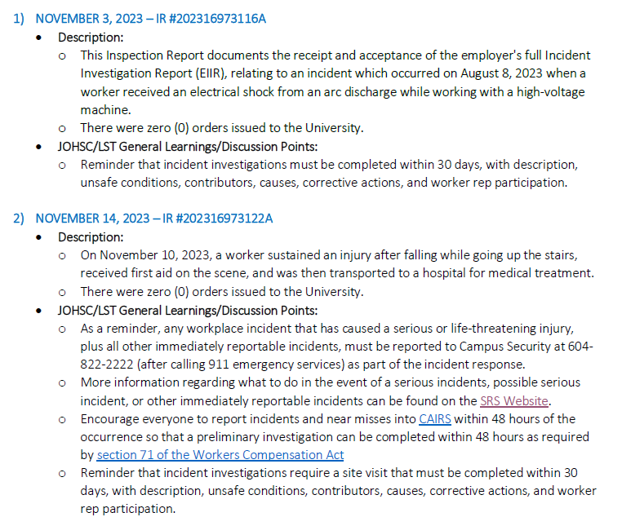

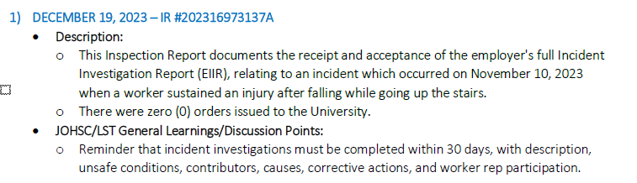
Sustainability Tips
None

- ONGOING BUSINESS – Status of Action Items (includes review of previous meeting minutes)
Items from JOHSC / RMS or other?
Original Item # | Priority | Action Plan  (Actions Taken/Need to be taken) | Assigned To | Follow up: Date Pending | Status
155 | C | Chemical Amnesty program and old gas cylinder disposal. The chemical amnesty program has successfully removed many hazardous and dated chemicals from both the MCML and FNH building at no cost to LFS. Further arrangement with SRS will remove dated gas cylinder situated at MCML gas room. AJ will follow up to see if this is a possibility. SRS may have run out of budget. AJ will check. SRS is still looking for budget. | AJ | Feb 28, 2024 | IP
159 | C | MCML 214/218 Brar Lab. Space was undergoing renovation at the time of visit so no inspection was performed. It is recommended that a visit be scheduled with SRS to complete the inspection once lab is set up. SH confirmed that the space is ready for this. AJ will contact SRS to arrange. | IK/SH/AJ | Nov 30, 2023 | IP
161 | C | MCML 102/112/120 Chemical Storage. It is recommended that peroxide formers be tested according to required scheduled.  For more info please see: chemical-safety-resources. Testing of peroxide formers must be documented on the peroxide former bottles. Each lab should identify the list of peroxide formers in the lab, categorize them by their class below.  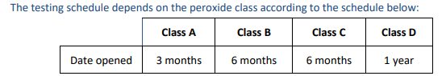  Once complete, each peroxide formers must be tested according to this schedule until they are completely consumed. Please check the below document for all peroxide formers: https://riskmanagement.sites.olt.ubc.ca/files/2023/04/CHEM-SWP-011-Working-Safely-With-Peroxide-Forming-Compounds-PDF.pdf | LF | May 31, 2024 | IP
162 | C | MCML 102/112/120 Chemical Storage. It is recommended that compressed gas cylinders be added to the inventory on Quartzy. JE and LF will go through and update at next meeting. | LF | Jan 19, 2024 | C
163 | C | In the compressed gas room, all cylinders must be secured. If needed, SRS can provide custom solutions for small cylinders. AJ said most small cylinders are ready to go so SL can call for them to pick up the empties. SL has called them to pick up. | AJ | Jan 19, 2024 | C
164 | C | Despite hydrogen gas and oxygen gas being stored in separate corners of the compressed gas room, it is highly recommended that they store in separate rooms. Investigate if this can be achieved. AJ will do an inventory of the gas room to see whether some tanks can go. There is no options to store them in separate rooms. This is the best option thus far. AJ suggests we move unused tanks for over 2 years to the front room for pick up. Many tanks have been picked up by Linde. An update inventory of gas cylinders will be done in the room to ensure proper storage of incompatible gases. | AJ/LF/IC | Feb 29, 2024 | IP
180 | C | A new item was added to re-open the discussion of a LFS Safety Coordinator. The main duties should include: to perform and follow up on safety inspections; to enforce safety rules; to host training sessions so they are consistently provided throughout the faculty; to review recurrent occurrence of deficiencies during inspections so as to target specific training during group meeting. Perhaps a joint position with Forestry. | AJ | Mar 30, 2024 | IP
181 | C | Each LST member walks around their labs, office area, and maybe ask their lab mates to brainstorm some ideas for improving sustainability in their spaces. Also, if possible, inquire about what their previous workplace did that we could learn from. Distiller water system consumes lots of running water and the old fume hood doesn’t shut off. Jack and Imelda will share what they have learn through the Green Labs Program in 2024 Feb meeting. | LF/JE/IC | Feb 29, 2024 | IP

- NEW & OTHER BUSINESS
Items from JOHSC / RMS or other?
Item # | Priority | Discussion and/or Action Items | Assigned To | Date to be Completed | Status
182 | C | Renew MCML LST Terms of Reference; Carly will join to replace Jimmy; the rest of members will continue. | IC | Jan 31, 2024 | N
183 | C | Safety committee structure for FBIC; assign to FNH LST | AJ | Jan 31, 2024 | N
184

- NEXT MEETING
Date: | Feb 16, 2024
Time: | 11:00 AM
Location | Remotely via Zoom or MCML 139

- MEETING ADJOURNED
Time: | 11:50 am

LEGEND

PRIORITY: |  | STATUS:
A | Critical/Life threatening/high probability | N | New
B | Urgent/moderate probability of re-occurrence | R | Repeat
C | Important/low probability of re-occurrence | C | Complete
D | Reminders | IP | In Progress
E | Information | RF | Referred forward

Send a copy of the meeting minutes report to the JOHSC. Highlight important items that must be reviewed/discussed at next JOHSC meeting.

Monthly Distribution and Posting of Approved Meeting Minutes (Required):
- All LST members
- Appropriate JOHSC
- Risk Management Service

