Local Safety Team Meeting Minutes

Name of Team: | MCML Local Safety Team | Chair(s): | Lewis Fausak

Date: | Mar 31, 2023 | Time: | 11:00 AM
 |  | Location: | Remotely via Zoom
AGENDA:
- Roll Call  - Review Central Accident/Incident Reporting System (CAIRS) report of Accidents/Incidents  - Monthly Incident List & Statistical Summary Report  - Review Workplace Safety Inspections (including any changes to equipment, machinery or work processes that may affect the health or safety of workers) | - Review Education and Training  - Ongoing Business – Status of Action Items, Review of Previous Minutes  - New and Other Business  - Next Meeting  - Meeting Adjournment

- ROLL CALL
Worker Representatives | Work Location | Present | Regrets | Absent
Imelda Cheung | MCML | ☐ |  | ☐
Alan Lee | MCML |  | ☐ | ☐
Sylvia Leung | MCML |  | ☐ | ☐
Jimmy (Juli Carillo’s grad student) Kyu Ha | MCML |  | ☐ | ☐
Lewis Fausak | MCML |  | ☐ | ☐
Thorsten Knipfer | MCML |  | ☐ | ☐
Jack Edgar | MCML |  | ☐ | ☐
Peter Kalynyak | MCML/Plant Care | ☐ | ☐
Employer Representatives | Work Location | Present | Regrets | Absent
Andy Jeffries | MCML |  | ☐ | ☐
Resources/Guests | Work Location | Present | Regrets | Absent
Samuel Holden | MCML | ☐ | ☐
Ishwinder Kamboj | MCML | ☐ | ☐

Approve Previous Month’s Minutes? Yes No ☐

- REVIEW CAIRS REPORT OF ACCIDENTS/INCIDENTS:
See attached incident report:
Monthly Incident List & Statistical Summary Report (make note of trends etc. For any general CAIRS information that requires discussion or action, please record under “New Business”. Any incident specific items and follow up requests are to be listed below)
(* See Legend at end for Priority and Status Codes)
Item #  (Use CAIRS Incident ID #) | Priority | Date | Action Plan  (Actions Taken/Need to be taken) | Assigned To | Follow up: Date Pending | Status
ID# 130900-130902 | E | March 2023? | Soap in eyes of employee at GH. Will have to follow up with PK. | PK | April 28, 2023 | N
ID# 130950 | E | March 13, 2023 | Agora had a grease fire in the bottom of their oven. LF sent preliminary inspection to Cody after learning he should be the person to submit the item. | AJ | April 28, 2023 | N
ID# 130095 | E | March 14, 2023 | TA almost fainted during lab. Will follow up with IC to learn more. | IC | April 28, 2023 | N
#ID 130095 | E | March 14, 2023 | Practicum student hit in the head with a hoop house piece and had to sit in the office. Will follow up with JM at UBC Farm. | AJ | April 28, 2023 | N

- REVIEW OF WORKPLACE SAFETY INSPECTIONS (including any changes to equipment, machinery or work processes that may affect the health or safety of workers)
Inspections for February: MCML 144/148,202 (AL), MCML 214,218 (IC), 192/194 (IC/LF/AJ), Greenhouse and Totem (MB,TS,AJ,LF,IC), Ext, Stairwells, General Interior (AJ/LF),
Inspections for March: None
Inspections for April: MCML 180C cold room (IC)
Item #  (Use Inspection #) | Priority | Discussion/Comments/Recommendations | Assigned To | Follow up: Date Pending | Status
MCML 308  M-46 | C | Chemicals in 308B are stored alphabetically and not by hazard class. Review chemical inventory and organize chemicals by hazard class. Lan will look up SDSs and the hazard class for each chemical in the space and tabulate in a google sheet. | PK/LF/IC | May 31, 2023 | IP
MCML 136  M-16 | C | Heavy items stored up high on shelves in 136C may cause injuries if they fall. Review items and condense; if necessary, move to lower shelves or install shelf ledges or ropes. | ZN/LF | Apr 30, 2023 | C
MCML 136B  M-16 | C | 136B is crowded and some items are piled up high, posing falling hazard to occupant in the room. Review inventory of items in the room and ensure storage bins are not piled above 6ft height. LF suggests that our work learn student can help tidy up this space. | ZN/LF | Apr 30, 2023 | C
MCML 136C  M-16 | C | Heavy items stored up high on shelves, at risk of falling to cause injuries. Review items to determine if they can be move lower or get disposed of. If they must stay, install shelf ledges or ropes or doors. LF will email ZN to initiate work. | ZN/LF | Apr 30, 2023 | C
MCML 144/148/48A  M-21 | C | Heating and ventilation not adequate in 48A. Inspect and evaluate to see what actions to take. Inquire whether the air quality evaluation will trigger some work on space. We are also investigating the exhaust fan at the same time. AJ will follow up on progress. Still awaiting response – AJ will update. Only a booster fan so things that got drawn up to the vent may come down at the other end of the room. AJ to check for further updates on what’s next step. Dust mask is used in the space and a maximum of 1 hr work in the space have been in placed as risk control measures. Put signage “Hoods not operational – please see Operations for training”. Protocols have been put in place such that workers in the space will not be exposed to dusts. Andy J will follow up with building ops next month to see if the hoods can be operational. The blower of the hood is broken and we are waiting for someone to come fix it. AJ confirmed that UBC building operations ordered and received the new fan unit and will be coming to fix it in early February. | CL/AJ | Feb 28, 2023 | C
MCML 26  M-19 | C | Missing documentation and records for safety and training in the space. There are only a couple of users at present in 26. Send an email to PI (Juli and Simone) to ensure they are aware of the need for training documentation and give them documents to help get them started with training set up. JH has commented that instrument manual is the only “safety” information provided and suggested perhaps troubleshooting guide is a more major part that should be covered since leaks will disable the sensors, rendering the chambers non-functional. IC will draft a brief training document for review. LF has reached out to Juli Carrillo regarding who should be supervising the space. Some users are reviewing the documents. Some maintenance protocols may be added, such as condensers, filters, etc. LF has added some details and it’s under review with AJ. The document is under review with Chelsea in Juli’s group. It’s almost complete. LF to prompt JC and JH to see if there are any updates. | LF/IC | April 28, 2023 | IP
MCML 180F  D-17 | C | A big hole in the ceiling was covered with duct tape. It is located at the left corner of the room. Have it assessed prior to submitting a service request to get it fixed. Consult with Andy. Service request has been submitted. Space was inspected, AJ met with crew members. AJ to contact SALA to inspect upstairs space. Do not see immediate concern as of now. | AJ | April 28, 2023 | IP
MCML 336  D-2 | C | Some lockers are full but with no owners. Empty contents to make available for room occupants. Notes were placed on lockers requesting to have them vacated by the end of the summer. | IC/LN | May 31, 2023 | IP
MCML 59  A-8 | B | Fire drill has been postponed due to the many projects occurring in the MCML building. A fire drill will be scheduled in early 2023. After discussion, AJ suggests it will be best to schedule for end of term 2 near end of April. Operations to meet and find a time, then suggest it on LFS today. We’ll still need to seek for new floor wardens. In next meeting, review floor warden list and recruit new candidates. Review BERP. | AJ | May 31, 2023 | IP
MCML 59  A-12 | B | Food safe concerns in facility due to general tidiness and sanitation practice. Dirty dishes were observed scattered over the place and knife was seen left on the counter unattended. Open food packaging was left out in unlocked facility overnight. It is recommended that the Agora Café review food safe practice to ensure daily clean-up is performed at the facility with the proper use of sanitizer. Food ingredients and materials should be locked in facilities to avoid chances of contamination and tampering by public. | Agora/  AJ | Mar 31, 2023 | IP
MCML 56  H-4 | B | One panel of cage #6 can no longer be closed properly as stacked boxes are tilting and pushing against the panel. Heavy boxes need to be re-positioned to alleviate pressure against the panel. Fix the cage panel so it can be closed. | AJ | Nov 30, 2022 | IP
MCML 56  H-20 | C | There are increasing clutters of materials outside of the cages. Users of cages should be advised to keep materials in the cages but not in the general access area in the room. IC to email PRSSS and other groups that have materials stored outside of assigned cages. PRSSS has started to do some work cleaning their cage. | LFS operations | Jan 31, 2023 | C
MCML 66  S-5 | C | Visual cracks observed on the ceiling (currently above the position of the pool table). Inspect water leaks from upstairs to follow up. | AJ | Apr 30, 2023 | IP
* GI- General Inspection

- EDUCATION AND TRAINING
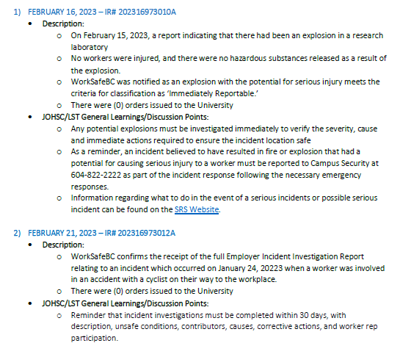

Sustainability Tips

May 20 - Free E-Bike Trial

Are you or your team interested in commuting to the office by e-bike?

E-biking is fun and a great way to be active, run errands, and commute to work. Thanks to electric pedal assist, you can effortlessly navigate the hills around campus and get where you need to go in an eco-friendly way. With the return of spring, there’s no better time to find out whether an e-bike is the right option for you.

That’s why UBC has partnered with Zygg to offer eligible faculty and staff with the opportunity to try an e-bike for free for a week. Between March 20 and May 20, 2023, eligible faculty and staff can register for a free 7-day trial with Zygg, a subscription-based e-bike rental service. Once you’re registered, a Zygg team member will reach out via email to coordinate your free trial.

You can learn more about the program and reserve your free trial here. Spots are limited so sign up today. If you have any questions, please contact active.transport@ubc.ca.

- ONGOING BUSINESS – Status of Action Items (includes review of previous meeting minutes)
Items from JOHSC / RMS or other?
Original Item # | Priority | Action Plan  (Actions Taken/Need to be taken) | Assigned To | Follow up: Date Pending | Status
121 | C | Revisit the need for biosafety permits for some laboratories in MCML as research activities continue to increase. Gurcharn’s research may involve risk groups 1 or 2 activities and perhaps require biosafety permit. Gurcharn’s research currently spans in different areas including MCML 214, 230 and 302. It is important to find out whether a biosafety permit is necessary, and whether the biowastes generated from research needs to be properly autoclaved prior to sending for disposal. Rupinder S is the new manager of the group and is working on getting the biosafety permit. AJ has emailed PI to inquire on progress. RS is working on implementing biosafety procedures/permit for the lab. RS is completing the biosafety training before he can apply for biosafety permit. As this researcher’s space is undergoing renovation (start mid-may) RS will process permit of internal room in 214. 214A will be the location for BSC and future cell culture work. Samuel has obtained the permit and should be posted in 214A. IC to follow up on obtaining the red tag/barcode sticker. Samuel has completed biosafety training, initiated the permit application but now awaiting PI to complete the biosafety training in order to continue the application. The red tag/barcode sticker cannot be obtained until the biosafety permit is obtained. In the meantime, IC has arranged with SRS to pick up unautoclaved wastes in yellow bins using IC’s tags/barcode. IC has noticed the used of biohazard sharp containers for general Risk Group 1 wastes. SL has confirmed she did not order them so lab has acquired those independently. IC will confirm how these are to be disposed of as these are non-reusable containers. The biohazard sharp containers should be tape-sealed, red tagged and put in chemical cage for pick-up. AJ will follow-up. IC will talk to Sam about the waste handling and AJ will chase after Gurcharn to complete the permit application. Sam has got the hazardous waste tags and barcode stickers for the lab, awaiting final permit application submission in March 2023 for the official biosafety permit. BSC and LFH in MCML 214 have been certified. | AJ/IC/RS | April 28, 2023 | IP
125 | C | A suggestion has been made to update the General Guide such that researcher will select the type of work areas (field, farm, office and/or lab), then the corresponding lab and field guides will follow. This will take time to test and implement and is expected to take on by the summer work learn student with some help from LC. LF will follow-up with learning center. Pop-up boxes seem more appropriate for other Guides after submission – IC will explore options on this. | IC/LF | May 31, 2023 | IP
140 | C | Antimicrobial copper plate installation at LFS buildings. AJ is in conversation to arrange for timeline for installation. AJ will be awaiting finalization of copper plate details before installation at MCML. AJ did not receive any updates but will email TECK for information. This conversation halted since Sept 2022 and the program funding should have depleted. AJ will follow up once more for updates next month – ran out of funding to keep this project. | AJ | Jan 31, 2023 | C
153 |  | MCML 180 C walk in cold room has broken down. It will take some time to fix. Temporary storage is moved to 230A. Installation of whole new cooling system will start end of January. Cooler has been fixed and is now operational | LFS operations | Feb 24, 2023 | C
154 | C | TK mentioned about a system in his lab that went offline during a short power outage. It is important that these outages are circulated to PIs/lab managers so that they can inspect the sensitive instruments that cannot reboot on its own. IC suggests to compile a list of important equipment from PIs in MCML so Operations will know to notify the PIs/lab manager or to take a look on the instrument in house. Specific time period of outage will be important to determine if experiments need to be re-done. Check with UBC IT/power team. A survey has been created to collect information on sensitive equipment at MCML (https://ubc.ca1.qualtrics.com/jfe/form/SV_4GfR6azRqxnZ6Mm ). AJ to submit form to LFS today and PI’s to determine equipment that should be on the list. | LFS operations | April 28, 2023 | IP
155 | C | Chemical Amnesty program and old gas cylinder disposal. The chemical amnesty program has successfully removed many hazardous and dated chemicals from both the MCML and FNH building at no cost to LFS. Further arrangement with SRS will remove dated gas cylinder situated at MCML gas room. AJ will follow up to see if this is a possibility. | AJ | Feb 24, 2023 | IP

- NEW & OTHER BUSINESS
Items from JOHSC / RMS or other?
Item # | Priority | Discussion and/or Action Items | Assigned To | Date to be Completed | Status
156 | C | Update MCML BERP and recruit new floor wardens. Can Carly take up Pierre/Martina’s spot. Invite Carly McGregor to become part of the LST and ask her to join the floor wardens (third floor). We can also ask Miluska Bravo to become another floor warden (first floor).  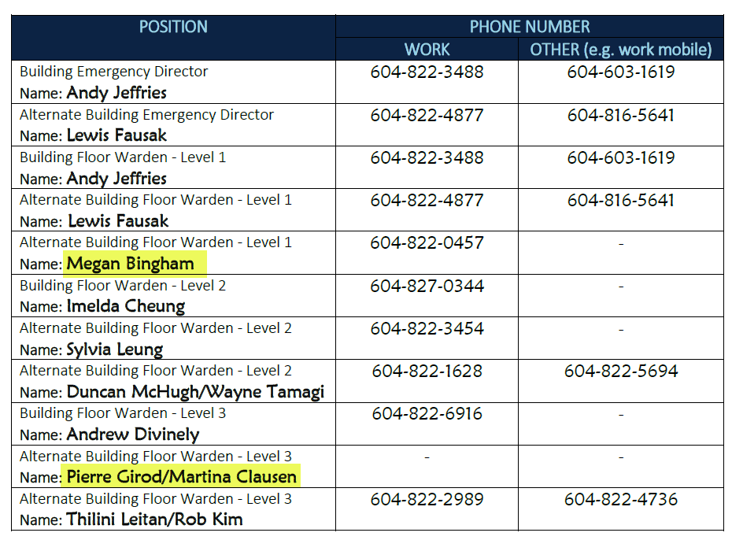 | LF | April 28, 2023 | N
157

- NEXT MEETING
Date: | Apr 28, 2023
Time: | 11:00 AM
Location | Remotely via Zoom or MCML 139

- MEETING ADJOURNED
Time: | 11:36 am

LEGEND

PRIORITY: |  | STATUS:
A | Critical/Life threatening/high probability | N | New
B | Urgent/moderate probability of re-occurrence | R | Repeat
C | Important/low probability of re-occurrence | C | Complete
D | Reminders | IP | In Progress
E | Information | RF | Referred forward

Send a copy of the meeting minutes report to the JOHSC. Highlight important items that must be reviewed/discussed at next JOHSC meeting.

Monthly Distribution and Posting of Approved Meeting Minutes (Required):
- All LST members
- Appropriate JOHSC
- Risk Management Service

