Workplace Safety Vehicle Guide
Faculty of Land and Food Systems

Driver Name: _____________________________
Driver Email Address: ___________________________________
Driver Emergency Contact Number: _____________________________________
Position:

☐ Volunteer
☐ Undergraduate
☐ Visiting Faculty/Student
☐ Graduate Student
☐ Postdoctoral Fellow
☐ Faculty Member
☐ Laboratory Assistant
☐ Research Assistant
☐ Lab Manager
☐ Research Associate
☐ Staff
☐ Other:

Supervisor Name: ____________________________
Supervisor Email address: _____________________________________
As a new member of the Faculty of Land and Food Systems, you must be provided sufficient information to safely work in our facilities and use our resources. We highly recommend that you go through the LFS General Guide – a comprehensive document that reviews UBC health and safety policies and procedures for all UBC workers.

This Vehicle Guide serves to supplement the LFS General Guide for students, staff, and faculty that will be using one of the LFS Vehicles for fieldwork and travel. All sections in this guide must be read and signed off by both the individual and his/her supervisor or principal investigator (PI) before using any LFS Faculty Vehicles.

https://my.landfood.ubc.ca/operations/policies-3/#faculty-vehicle-0

- New Vehicle User Safety Orientation Checklist
☐ Users acknowledge that they have a valid driver's license (Canadian or International), see ICBC guideline (see ICBC guidelines http://www.icbc.com/driver-licensing/moving-bc/Pages/Moving-from-another-country.aspx). L drivers are restricted from using the LFS Vehicles, and N drivers may be approved on a case by case basis.

IF you have an N driver’s license, please send a detailed email to lfs.facilities@ubc.ca detailing your situation with research/travel, highlighting how you intend on ensuring you meet the requirements of your license class and copying it to your direct supervisor.

☐ Vehicles are only to be driven within British Columbia.
☐ Know where the emergency equipment is located in the vehicle (includes: safety vest, first aid kit, booster cables). Typically, these are under or behind the seats.
☐ Know the location of the “What to do in the case of an accident form” in the glove compartment of each vehicle.
☐ Know the location of first responder phone numbers (e.g. Hospital, Security, and First Aid) closest to you. At UBC you can call 1-604-822-4444 for first aid. When in doubt, call 911.
☐ Ensure all drivers and passengers are using seat belts for the duration of the drive.
☐ All drivers are prohibited from operating a vehicle while impaired due to substances, fatigue, and/or aggression.
☐ All drivers will incorporate 15-minute breaks into their driving schedule at least once every two hours when safe to do so. Driving more than 12 hours continuously is strictly prohibited.
☐ All drivers are prohibited from using cell phones and other electronic devices while driving, even hands-free.
☐ All distracted driving is prohibited, including eating while driving.
☐ Using sunglasses to prevent eye strain is recommended.
☐ Plan out your trip in advance to know where you are going and any potential hazards on the road, from usual hazards (distracted drivers, speeding, improper lane changes) to high risk or unusual hazards (high use intersections, parking near busy roads, winter conditions, difficult routes, etc.).
☐ If you are bringing equipment with you, ensure that all equipment is secure in the back of the truck or van and will not move while driving. Ratchet straps and bungee cables are provided in the Ford Ranger. If they are not present, please contact lewis.fausak@ubc.ca to obtain more.
☐ If you are using a vehicle for the first time, ensure you book extra time to familiarize yourself with the vehicle features and review the manual if needed.
☐ Adjust the driver’s seat, rear, and side-view mirrors before leaving on your trip.
☐ Remember to complete the daily “Before You Go” Checklist located in each vehicle.
Before you go! Have you….
□ checked the interior condition (cleanliness?)
□ checked the exterior condition (new bumps or scratches?)
□ checked for any warning lights on dash?
□ left enough time during your booking to clean the vehicle and fill up with gas as required?

If there is an issue with the vehicle, please report it by filling in the form in the keychain and notifying lewis.fausak@ubc.ca. Photos are appreciated.
Cleaning supplies are located in the filing cabinet in the basement stairwell, please email Lewis if items are running low.

- Bookings
☐ All vehicles owned by the Faculty of Land and Food Systems (LFS) must be booked through the online booking service. Bookings are on a first-come, first-serve basis.
☐ Bookings must be made in advance. Internal LFS faculty & staff are allowed block bookings for a maximum of 2 weeks. External users (any non-LFS faculty or staff) are allowed to block bookings up to a maximum of 5 days in total.
☐ There must be a valid speed chart provided to book a vehicle. For external users and LFS students, a supervisor’s name is required to authorize the use of the speed chart. If NO speed chart is provided, NO vehicle will be rented.
☐ Priority for vehicle use will be given to LFS faculty & staff. Accordingly, for bookings made on the same day, priority will be given to internal users over external users. Internal users are allowed to “bump” external bookings, given that a notice of 2 business days is provided for emergency reasons. Please notify Daphne Wang (daphne.wang@ubc.ca) who will evaluate the appropriateness of your reason. If Daphne is unavailable, please notify Lewis Fausak (lewis.fausak@ubc.ca).
☐ Vehicle keys can be picked up from the finance department (MCML 254) between the hours of 8:30 AM and 4:00 PM. Please note that there is a 24 hour (working days only) turnaround time for request confirmation. Please do not take a vehicle without confirmation, as there may be a request ahead of yours that simply has not yet shown up on the booking page.
☐ Upon return of the vehicle, users must complete the Vehicle Use Form (provided in the key chain pocket or QR code in the vehicle). The vehicle keys, completed Vehicle Use Forms, and original gas receipts must be returned to the LFS staff member responsible for vehicle bookings. If after hours, please return the key to the dropbox outside of MCML 254.
- Information Regarding Acceptable Use

☐ The Toyota Prius is not to be used for fieldwork of ANY kind.
☐ The Toyota Prius and Dodge Caravan are intended for use on paved roads only.
☐ The Chevy Colorado is generally used for short travel.
☐ The Toyota Prius and Ford Ranger are equipped with tires that can be driven below 7⁰C, the Dodge Caravan should not be driven in winter conditions.
☐ Before leaving, complete a walk-around of the vehicle to note any damage or issues. Things to inspect include: front and rear fender, side panels of the vehicle, tire inflation, windshield wiper condition, lights working, no signs of fluid leaks, cleanliness of the vehicle, and warning lights. Photograph and/or report any issues before departing with the vehicle to the technician responsible (lewis.fausak@ubc.ca). Failure to submit information can result in charges for repairs or cleaning billed to your account.
☐ Return the vehicle to the correct parking spot. For the Dodge Caravan, Ford Ranger, and Prius, these are stalls R273, R274, and R275 between MacMillan Building and the Frank Forward Building and for the Chevy Colorado, it is behind the gate at Totem Field. Users who park in the incorrect parking stalls will be asked to move them immediately and will be responsible for any costs incurred from ticketing or towing. A financial penalty may be applied to your speed chart for infractions.
☐ A Vehicle Report form is also included in the keychain or through QR code; complete the form to report damage to the vehicle or provide other comments (i.e. cleanliness of the interior). For any vehicle damage, please notify lewis.fausak@ubc.ca by email that a form has been completed along with any photographs of vehicle damage. These forms will be picked up from finance by the technician responsible for each week.
- Fees and Charges

☐ External bookings made by any non-LFS faculty or staff member will be charged a fee of $40 per day.
☐ Vehicle mileage will be charged at the current rate of $0.59 per kilometer driven, effective July 1, 2016.
☐ Any lost keys will be charged a minimum of $300 to the speed chart, and additional fees will be charged if costs exceed the key replacement price.
☐ Pets and smoking are NOT permitted in any vehicle at any time. Any breach of this will result in a loss of privileges and a minimum $100 cleaning fee.
☐ Ensure vehicles are returned in a clean condition, inside and out. Failure to do so will result in a minimum $50 charge to the user’s speed chart. It is the responsibility of the users to keep the car clean. Report any unclean vehicles, failure to do so will result in a cleaning charge to the last user’s speed chart.
☐ The extra key on the FOB can be used to unlock the cleaning supply filing cabinet located in the MacMillan stairwell on the ground floor (MCML 48C). Cleaning supplies, vacuums, and an extension cord can be located here.
- Liability

☐ Late Return Fees: If a vehicle is returned beyond the time booked, a late fee of $50.00 will be accessed to the user speed chart. A grace period of 30 minutes will be afforded to all vehicle users. Exceptions to this policy will be applied if it is deemed that the user has encountered difficulties in returning the vehicle on time due to mechanical problems (i.e. flat tire) or problems beyond their control (i.e. traffic delays, construction delays). If a vehicle is returned late a second time the late fee will be doubled, the fee will be tripled if a vehicle is returned late a third time. Beyond this period of “late returns” borrowing privileges will be suspended.
☐ Vehicles must be used for UBC business purposes only. If they are being used for purposes other than LFS related matters, and the driver has an accident, the driver will be held liable and his or her insurance premiums will increase. If the vehicle is being used for LFS purposes and the driver has an accident, the university will be held liable and its insurance premiums will increase. The $500 deductible will be charged to the unit responsible.
☐ Any accident must be reported immediately. The driver must complete the Vehicle Accident Report located in the glove compartment of each vehicle. An online version of this report is available at http://rms.ubc.ca/insurance/insurance-programs/automobile-insurance/. Follow the instructions in the accident report on how to report a claim to ICBC and when to notify additional services, such as RCMP. The driver must notify their supervisor of the incident as well as Lewis Fausak (lewis.fausak@ubc.ca), Andy Jeffries (andy.jeffries@ubc.ca) and Daphne Wang (daphne.wang@ubc.ca). If the vehicle has sustained damage that renders it undrivable, the vehicle is to be towed to the correct parking spot or alternate approved location.
☐ All traffic violations, including parking fines and speeding tickets, are the sole responsibility of the person requesting use of the vehicle.
- Fueling and Cleaning

☐ Vehicles must be returned with a minimum of ½ tank of fuel.
☐ Two options for fueling up exist: (instructions provided in the vehicle glove box):

Option 1: Fueling Up on Campus
1. The campus fuel pump is located in front of the University Services Building. 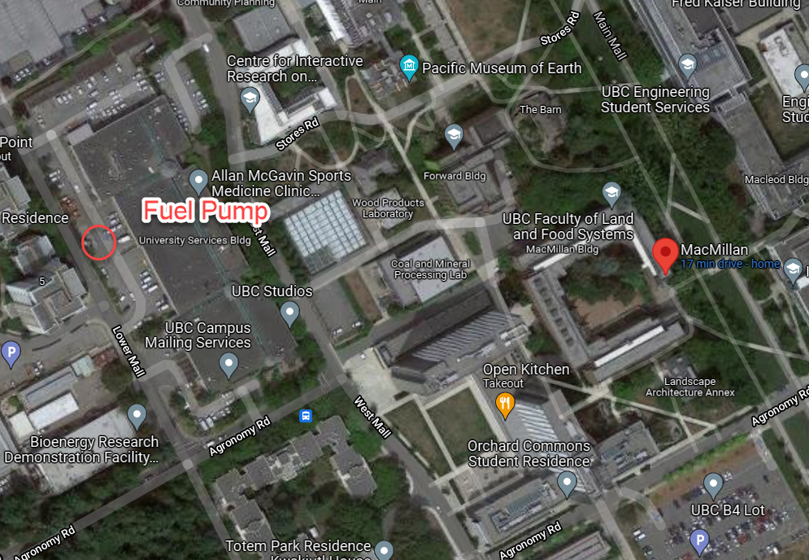
Parked Vehicles
2. Record the vehicle mileage, turn off the vehicle, open the fuel cover, and unscrew the cap.
3. Make sure the pump switch is turned off (flipped down) and use the scanner to scan the RFID chip inside the gas cap (should hear a beep)
4. Enter the mileage onto the pin pad and press enter (this may take several attempts) and enter the driver code 9999 and press enter. Should read “authorized”.
5. Flip the pump to on (flipped up), insert the gas nozzle into the vehicle, and begin fueling up.
6. When you hear a click, return the nozzle to the pump, and switch it off.
7. See the fueling document located in the glovebox for more information.

Option 2: Fueling Up Off-Campus (out of pocket)
1. Pull up alongside the fueling station with the fuel cap on the same side as the pump.
2. Turn off the vehicle, open the fuel cover, and unscrew the cap.
3. Use your payment method to select gas for the vehicle.
4. Insert the nozzle and fuel up until you hear a click.
5. Return the nozzle and print out your receipt.
6. If the fuel amount is less than $50, ask Daphne Wang for cash reimbursement and submit your receipt to her. If it is greater than $50, save your receipt and submit your expense claim on Workday.
7. For assistance with workday submission visit: https://ubc.service-now.com/selfservice?id=kb_article&sys_id=c41865b41be2b4900dbaec21b24bcb94&table=kb_knowledge
8. For more details see the fueling document (Expense item: Travel Vehicle and Rental Fuel, Program: PM009555, Cost Center: CC00273, Additional Worktags: FD000)
☐ If the exterior of the vehicle becomes dirty during use, it is the user’s responsibility to clean the vehicle before its return. Please see Section C above for "Information Regarding Acceptable Use". Receipts for reimbursement can be submitted to Daphne Wang (under $50) or through WorkDay (over $50).

- Maintenance

☐ Vehicles will be checked by an LFS technician monthly for general drivability, including fluid levels, tire pressure, and a visual check for damage or leaks.
☐ If the vehicle has been booked for more than one day, the user is responsible for checking the above items.
☐ All defects must be reported using the Vehicle Report (mileage slip) and forwarded to lewis.fausak@ubc.ca.
- Security

☐ It is the driver’s responsibility to ensure the vehicle is locked and all lights are out when left unattended. Unless otherwise advised, vehicles must be parked in the “O” lot directly behind the MacMillan building (Stalls R273, R274and R275 ONLY).
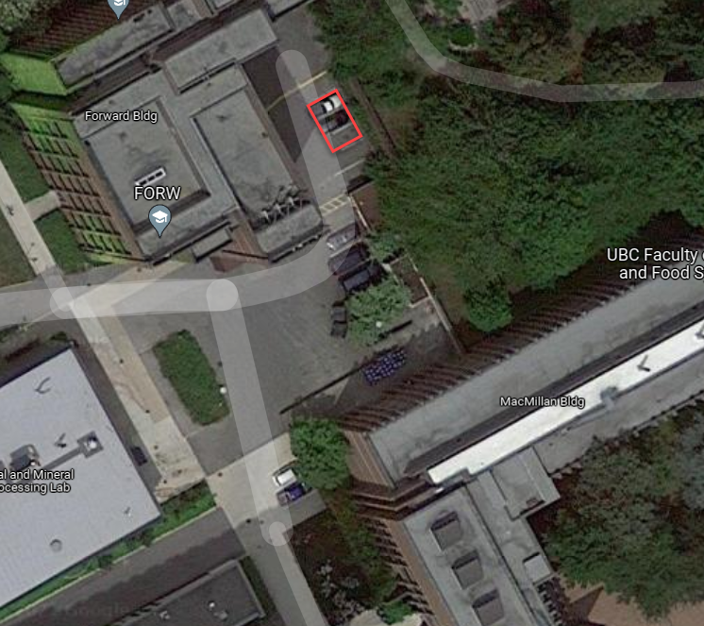
☐ Users that are unable to return vehicle keys until the next business day are required to leave a message at one of the numbers below. Outstanding keys must be returned no later than 9:00 AM the following day:
- Finance Office (Room 254) – Daphne Wang 604-822-2193
  - Faculty Technician – Lewis Fausak 604-816-5641

After reading through Sections A – H above, please meet with your supervisor or PI to discuss any unclear points. If necessary, consult with a member of the LST.
https://my.landfood.ubc.ca/operations/health-safety/

***************************************************************************************************************
☐ I understand the items that were discussed on this form, the basics of driving safely, and the LFS vehicle policy described in sections A – H above.

☐ I understand that any accident must be reported immediately and the driver must complete the Vehicle Accident Report.

☐ I understand that in case of any accident, I must notify my supervisor as well as Lewis Fausak (lewis.fausak@ubc.ca), Andy Jeffries (andy.jeffries@ubc.ca) and Daphne Wang (daphne.wang@ubc.ca).

☐ I understand that if I fail to follow the LFS vehicle policy in Sections A - H, additional fees may be charged and future booking privileges could be restricted.

Driver Name (print): _____________________

Signature (e-signature accepted): __________________________

Date:____________________

- A copy of this will signed guide will be sent to your Supervisor/Designate

Upon completion of this form, please upload an electronic version of this signed form to https://training-report.landfood.ubc.ca. If you are having difficulty with this step, please contact lfs.facilities@ubc.ca or lewis.fausak@ubc.ca .

